**FLAPPY BIRD**

**Project Synopsis**

**Version 1.0**

Industrial Training & Presentation (ECS 791)

**BACHELOR OF TECHNOLOGY (CSE)**

|  |  |
| --- | --- |
| PROJECT GUIDE:  **Ms. Rohaila Naaz** | SUBMITTED BY:  **Aman Madhok (TCA1809023)**  **Kshma Sethi (TCA1809072)** |

December, 2021



**COLLEGE OF COMPUTING SCIENCES AND INFORMATION TECHNOLOGY**

**TEERTHANKER MAHAVEER UNIVERSITY, MORADABAD**

**Table of Contents**

1 Project Title 3

2 Domain 3

3 Problem Statement 3

4 Project Description 3

4.1 Scope of the Work 3

4.2 Project Modules 3

5 Implementation Methodology 4

6 Technologies to be used 5

6.1 Software Platform 5

6.2 Hardware Platform 5

6.3 Libraries 5

7 Advantages of this Project 5

8 Future Scope and further enhancement of the Project 5

9 Team Details 6

10 Conclusion 6

11 References 6

# Project Title

Flappy Bird

# Domain

* Technical Domain- Pygame
* Business Domain- Gaming

# Problem Statement

Our objective for this project is to implement the game on computer screen. We try to create user-friendly interfaces to allow user better understand the game instructions and workflows. The game allows users to choose playing modes and background settings, and to control bird using keyboard buttons. It also contains a score board function to track previous history.

# Project Description

The In this project, we design and implement a Flappy Bird like video game. Flappy Bird is a very popular mobile game on Android platform, driving a lot of people crazy. In this game, the player can control the vertical movement of bird (every pressing on the keyboard makes the bird leap upward for a little bit, and the bird will fall freely without control). As soon as the game begins, tubes will keep appearing from the right side of the screen and moving leftwards. (So that it seems like the bird flying forward). The goal of this game is to control the bird, dodging and passing the incoming tubes, as many as possible. The game is endless until the bird eventually hit one of the tubes, ground, or ceiling.

## Scope of the Work

Our design process is to first create the static interfaces. Then we started to create single player mode, including pipe and background shifting, bird falling or jumping, score and life tracking, sound effect

## Project Modules

* **Main Screen**- It will display the welcome screen on starting the game. We start by assigning the values of the x-coordinate and y-coordinate for the player, message, and title images. Here we make use of a [for loop](https://www.askpython.com/course/python-course-for-loop) for analyzing all the events taking place throughout the game using pygame.event.get() function. Then we check that whenever a quit type of event is encountered by pressing the escape key, the game window will close.
* **Gameplay**- This is the main module, Defining the variable score as 0, bird velocity, minimum bird velocity, maximum bird velocity, and pipes velocity. Handle the key events using pygame.event.get() and checking for the game is over or not if it is over return from the function. Updating the score and in game images such as background, pipe, and bird on the window.language.
* **Colliding**- represents whether the bird has hit the pipes or fall into the sea. According to my thought, three conditions lead to a situation of the game over. if the difference between our elevation and a certain height is less than vertical it means the bird has crossed its boundaries resulting in a game over and if the bird hits any of the lower and upper pip then this will also lead to game over condition.
* **Random Pipes**- generates a new pipe of random height. First of all, we have to fetch the height of the pipe using getheight() function. After this generates a random number between 0 to a number (such that the height of the pipe should be adjustable to our window height). After that, we create a list of dictionaries that contains coordinates of upper and lower pipes and return it

# Implementation Methodology

**Step 1:** In this first step, we have to import libraries.

After that, we have to set the height and width of the screen to which the game will be played. Now we have to define some images which we shall use in our game like pipes as hurdles, bird's images, and also a background image of the flappy bird game.

**Step 2:** After declaring game variables and importing libraries we have to initialize the Pygame.

Initialize the program using pygame.init() and set the caption of the window. Here pygame.time.Clock() will be used further in the main loop of the game to alter the speed the bird. Load the images from the system in pygame using pygame.image.load().

**Step 3:** Initialize the position of the bird and starting the game loop

Initialize the position of bird and sea level to the ground. Adding conditions in the loop defines the game conditions. The variable horizontal and vertical is used to set the position of the bird. We have to run the program until the user stops or exits (using sys.exit()) if the program so, we create an infinite while loop.

**Step 4:** Create a function that generates a new pipe of random height

First of all, we have to fetch the height of the pipe using getheight() function. After this generates a random number between 0 to a number (such that the height of the pipe should be adjustable to our window height). After that, we create a list of dictionaries that contains coordinates of upper and lower pipes and return it.

**Step 5:** Now we create a GameOver() function which represents whether the bird has hit the pipes or fall into the sea.

According to my thought, three conditions lead to a situation of the game over. if the difference between our elevation and a certain height is less than vertical it means the bird has crossed its boundaries resulting in a game over and if the bird hits any of the lower and upper pip then this will also lead to game over condition.

**Step 6:** Now we will be creating our main function (flappygame()) that will do the following things:

Initialize the variables and creating two pipes by createPipe() function. Create two lists first is of lower pipes and the other is of lower pipes. Defining the bird velocity, minimum bird velocity, maximum bird velocity, and pipes velocity. Handle the key events using pygame.event.get() and checking for the game is over or not if it is over return from the function. Updating the score and blit game images such as background, pipe, and bird on the window.

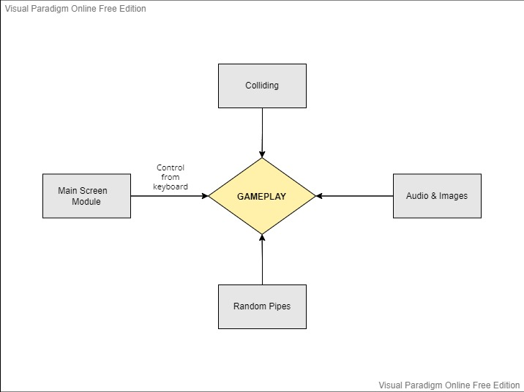

# Technologies to be used

## Software Platform

* Operating system- Windows 7 or higher versions
* Programming Language- Python 3.8 (Install Conda for python)

## Hardware Platform

RAM, Hard Disk, OS, Editor, Browser etc.

## Libraries

Pygame, sys, random.

This project was done with “Pygame”.Pygame is a cross-platform set of Python modules which is used to create video games. It consists of computer graphics and sound libraries designed to be used with the Python programming language.

Python Random module is an in-built module of Python which is used to generate random numbers. These are pseudo-random numbers means these are not truly random.

It provides various functions and variables that are used to manipulate different parts of the Python runtime environment.

# Advantages of this Project

* Clear goals: an objective is distinctly defined with immediate feedback – you know instantly how well you’re doing.
* Concentration on the task at hand; irrelevant stimuli disappear from consciousness; worries and concerns are temporarily suspended.
* Altered sense of time, which usually seems to pass faster.

# Future Scope and further enhancement of the Project

* We want to create the bird rotating effect when jumping or falling.
* We are working on adding a multiplayer mode. This gives users the opportunity to compete with their friends.
* Also, we can increase the game difficulty by decreasing the gap between pipes as time goes on.
* Finally, we can increase the game difficulty by making pipes move up and down as time goes on.

# Team Details

|  |  |  |  |  |  |
| --- | --- | --- | --- | --- | --- |
| **Group#** | **Course Name** | **Student ID** | **Student Name** | **Role** | **Signature** |
|  | Industrial Training & Presentation (ECS 791) | TCA1809023 | Aman Madhok | Developer |  |
| TCA1809072 | Kshma Sethi | Developer |  |

# Conclusion

Our final project was planned, developed and demonstrated as expected. We designed a new version of Flappy Bird Game written in Python, which could be played on personal computers. Firstly, a user-friendly interface was implemented. and realized. It relies on gravity so User has to press Spacebar to keep the bird flying and pass tunnels, Final scores will be displayed and if the bird touches the ground or the tunnel, game restarts. It is simple yet difficult game, which will bring a lot of fun.

# References

[1] [*"Flappy Bird Game"*](https://us.norton.com/internetsecurity-iot-how-facial-recognition-software-works.html)*.*  *August 18, 2020 by [adones evangelista](https://itsourcecode.com/author/adonesevangelista/" \o "View all posts by adones evangelista)*

[2] *Flappy Bird* *CSEE 4840 Embedded system design*

[3] Flappy Bird (31 August 2021). GeeksForGeeks

[4] https://www.pygame.org/news

[5] *https://www.askpython.com/python*